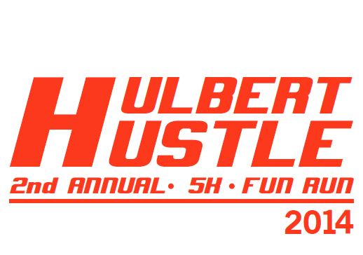
Sponsorship Form

I am interested in supporting the Hulbert Hustle 5K and Fun Run through one of the following sponsorships

Mark Level  (X) | Corporate Sponsorship Levels  (Please mark only one) | Donation
 | Gold  Company name large print on shirt, company name on event website, company literature in race packets. | $200 +
 | Silver  Company name small print on shirt, company name on event website, company literature in race packets. | $50-$200

Company/Club Name/Individual: ___________________________________________

Donation Amount: _______________________ Cash or Check #: _____________

Contact Person: ________________________________________________________

Address: ______________________________________________________________

City: __________________________________ State: _____ Zip: _________________

E-mail: ________________________________________________________________

Phone: _______________________________________________________________

Make checks payable to: FBC Hulbert

Mail payment & form to:
Brigette Manes
PO BOX 208
Hulbert, OK 74441

Please return form by April 1, 2014

Thank You!

